Katja Brose, PhD
Editor, Neuron
Cell Press
600 Technology Square 5th Floor
Cambridge, MA 02139
mlemasurier@cell.com

Dear Katja,
We submit our manuscript entitled: “Identification and Targeting of Cortical Ensembles with Graphical Models” for consideration as a NeuroResource. In a combined theoretical/experimental approach. we use a novel machine learning method to infer the network connectivity of neural circuits in mouse primary visual cortex from two-photon calcium imaging and optogenetics. With this method, we can accurately predict the visual stimuli (gratings of different orientation), optimally detect neuronal ensembles, identify the neurons with pattern completion properties and finally, capture the changes in the network after two-photon reconfiguration.
Our work represents a combination of cutting-edge machine learning with cutting-edge two-photon optogenetics in awake animals. Our method is novel, as graphical models, which are one of the workhorses of machine learning, have not yet been exploited by neuroscientists to decipher neuronal circuits. It is also of general interest as it provides an effective method to detect neuronal ensembles and identify the critical neurons for optogenetic manipulations.
As reviewers we recommend Rossa Cossart, Olaf Sporn, Giuri Buszaki, Thomas Mrsic-Flogel and David Heeger. Unfortunately, Andreas Tolias and Matteo Carandini are involved in similar work and have conflict of interest.

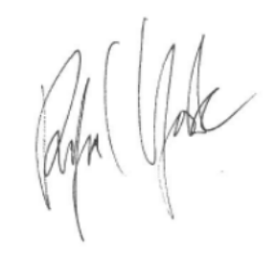
Best Regards

Rafael Yuste, M.D. Ph.D.
Professor of Biological Sciences and Neuroscience
Director, NeuroTechnology Center
Co-Director, Kavli Institute for Brain Science

